Managed Switch

⚙️ What is a Managed Switch?
# Source: Chatgpt (GPT‑5 Mini) at [12/18/2025]
A Managed Switch is an advanced type of network switch that gives full control over your network. Unlike unmanaged switches, which are plug-and-play, managed switches allow you to configure, monitor, and manage network traffic to improve performance, security, and reliability.
Used mainly in business, enterprise, or data center environments.

🔧 Key Features of a Managed Switch
# Source: Chatgpt (GPT‑5 Mini) at [12/18/2025]
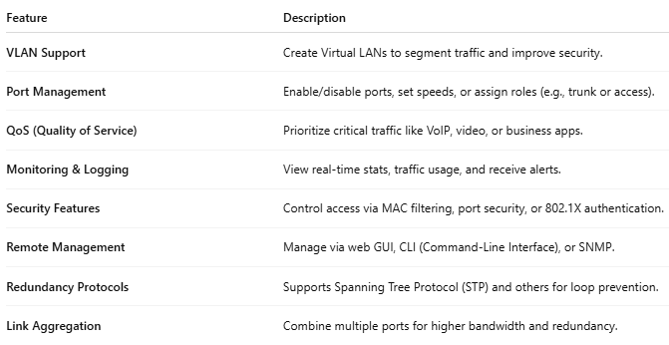
Feature | Description
VLAN Support | Create Virtual LANs to segment traffic and improve security.
Port Management | Enable/disable ports, set speeds, or assign roles (e.g., trunk or access).
QoS (Quality of Service) | Prioritize critical traffic like VoIP, video, or business apps.
Monitoring & Logging | View real-time stats, traffic usage, and receive alerts.
Security Features | Control access via MAC filtering, port security, or 802.1X authentication.
Remote Management | Manage via web GUI, CLI (Command-Line Interface), or SNMP.
Redundancy Protocols | Supports Spanning Tree Protocol (STP) and others for loop prevention.
Link Aggregation | Combine multiple ports for higher bandwidth and redundancy.

🏢 Common Use Cases
# Source: Chatgpt (GPT‑5 Mini) at [12/18/2025]
- Segmenting departments in a business using VLANs
- Prioritizing video calls and VoIP traffic using QoS
- Securing access to network resources
- Monitoring bandwidth usage and traffic patterns
- Creating failover links and redundancy in large networks

🖥️ Example Network Setup
# Source: Chatgpt (GPT‑5 Mini) at [12/18/2025]
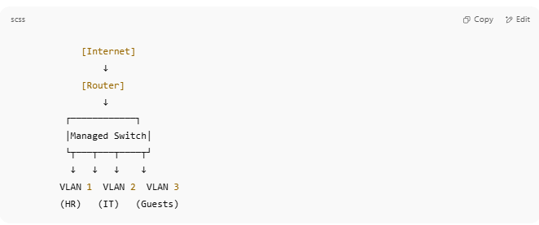

[Internet]
↓
[Router]
↓
┌────────────┐
│Managed Switch│
└┬───┬───┬────┬┘
↓ ↓ ↓ ↓
VLAN 1 VLAN 2 VLAN 3
(HR) (IT) (Guests)

🆚 Managed vs Unmanaged Switch
# Source: Chatgpt (GPT‑5 Mini) at [12/18/2025]
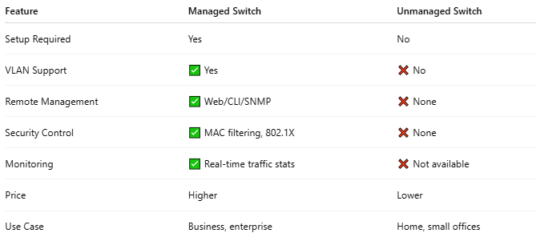
Feature | Managed Switch | Unmanaged Switch
Setup Required | Yes | No
VLAN Support | ✅ Yes | ❌ No
Remote Management | ✅ Web/CLI/SNMP | ❌ None
Security Control | ✅ MAC filtering, 802.1X | ❌ None
Monitoring | ✅ Real-time traffic stats | ❌ Not available
Price | Higher | Lower
Use Case | Business, enterprise | Home, small offices

🎯 Common Brands and Models
# Source: Chatgpt (GPT‑5 Mini) at [12/18/2025]
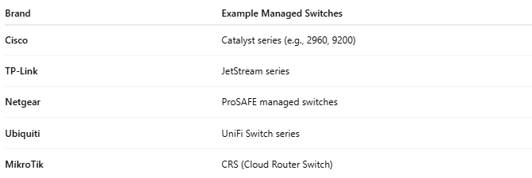
Brand | Example Managed Switches
Cisco | Catalyst series (e.g., 2960, 9200)
TP-Link | JetStream series
Netgear | ProSAFE managed switches
Ubiquiti | UniFi Switch series
MikroTik | CRS (Cloud Router Switch)

